Personal Care Plan for Name ___________________________________ DATE: _________________________________________

Action | Reflect | PLAN
Connect to Your Purpose/Calling/Why | Why are you doing this work?  What is your “why”? | I am called to nursing because ….  As a nurse I want to …
Practices I can do to access my feelings/heart | How do you know when you are “out of sorts”? How do you access your feelings? What helps you access your feelings?
Practices I can do to check in w/ my body (before and /or after work) | How does your body carry its stress? How does your body let you know it is stressed?  What do you do to physically release your stress?
Ways to ground myself in the my shift/ in the flow of the day; | How can I check in, in the busyness of my day/flow?  How can I ground myself?
Practices at the end of my day/shift to “let go”; | How do you grieve? How do you leave things at the door before you come home?
Support network | Who is in your extended support network?  Therapist, Coach, mentor, Pastor/Rabbi/Chaplains | (See diagram below)
On-going ways to connect to my heart/ to care for myself (Quarterly/Monthly) | How might you have some “pre planned” or “hard-wired” ways to check in?

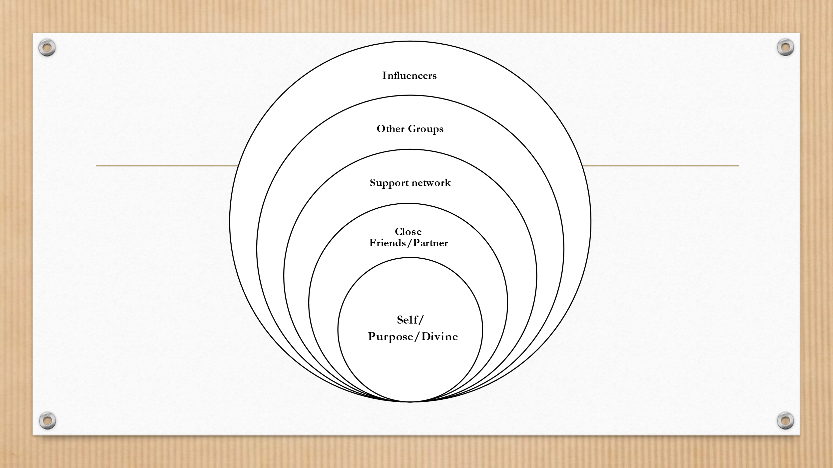

Examples of Practices:
WHAT | WHEN /HOW
Connect to Why | Name it, use when you are having a hard day and wondering, “why” am I doing this again? When you might be disillusioned or doubting your calling.
3 Breathes | Use in the midst of your shift to help ground, connect in the moment;
Hand-Washing Grounding | Each time you wash your hands, use it as time to reconnect to the present moment. To ground yourself, to be present to the patient you are about to see, to release the patient you just saw.
Body Scan | Use this as a way of getting curious about what your body has to say to you. In your mind’s eye, using your breath, check in w/ each area of your body and notice where you are carrying tension, notice what you are feeling (head, neck, shoulders, gut, arms, legs and yes, feet!)
Building a threshold | Think about creating a buffer between what you bring in from a shift and your “place” of home, refuge, loved ones etc. This could be using the commute as a time to process the day and release it, it could be a symbol before you walk in the door to leave things at the door. (You can pick them up the next day if you need to.)
Grief Ritual : Prayer, release, | Notice how you process grief. Everyone is different. Rituals are really important in being with and releasing grief. It can be symbolically placing what you are carrying in a bowl (like w/ a rock or piece of paper), it could be in the form of a prayers, it could be seeking out other support. The key here is be aware of it AND TEND to it!
Permission Slip to reach out | Write yourself a permission slip if you need to, to take care of yourself, to reach out. Treat it like an Rx prescription if you need to. This is your compassionate self, caring for your “working” “dutiful” self. Pay attention to the stories you are telling yourself, like: “I am strong, and a strong professional nurse toughs it out.” “As a professional I need to put my feelings away (not to be looked at ever) and tamp them down.” “ I don’t want to seem “weak” to my peers. “ “I shouldn’t be having these feelings/reactions etc. I’m a professional.” “Press on, this is what we do as caregivers.” “Everyone else first..”
Retreats | Plan ways to get away on a regular basis. Get aways where you are not having to “take care” of others, and can focus on what your heart is needed. I could be a short retreat like 4 hours on a day, or longer.
Therapist/Mentor | Know who you can go to and who is holding your best interest and care.
Buddy connections | Have some peers where you can debrief and process things that come up.
Hobbies outside of Work | Make sure you have an “other” life! Something else that also feeds you!
Walks in nature/ beauty, art, creative practices (get out of head) | Do something that invites the other side of your brain to engage!
Yoga | This is a great practice for physical connection. It also invites you to be in touch w/ your body and what wisdom the body has for you. It is also relaxing and allows for some emotional release.
Meditation/ Mindfulness/ Prayer | This is your where you can make time to tend to your “inner life” which forms and frames your outer life, whether you are aware of it or not. It is a way to connect to something greater than yourself, reinforces your purpose and meaning and offers space for grounding and intentionally tending to your spirit.
Music | This permeates your “head” and can open and cleanse your heart in powerful ways. It is also a great release (imagine and “dance it out” kind of experience!) .
Animal Therapy | Animals have a gift of speaking to our hearts in ways that by-pass our heads.

